#include <stdlib.h>

#include <stdio.h>

// Franklyn Gonzalez, last edited 02/07/2019

void triangle(char color[]) {

int i; // space used to count amount of characters printed

int rows = 10; // number of rows, from all the odd numbers starting with 1 to 19, which totals to 100

int k = 0; // used for the while loop - for odd number rows

int count = 0; // counter variable for while loop

for (i = 0; i <= rows; ++i) // number of rows, which is 10

{

while (k != 2 * i + 1) // statement for odd numbers per each row on the pyramid

{

if (count <= rows - 1)

{

printf("%c", color[i]);

++count;

}

else

{

printf("%c", color[i]);

}

++k; // meets "k" and ends loop if the while statement is true with equation

}

count = k = 0;

printf("\n"); // starts the new row for the pyramid

}

}

void vertical(char color[], int count2) {

for (int i = 0; i < 99; i++) {

if (color[i] == '\0' && count2 + 1 <= i)

{

printf(""); // eliminates nasty empty spaces

}

else

{

printf("\n%c", color[i]);

}

}

printf("\n");

}

void backwards(char color[], int count2) {

for (int i = 98; i >= 0; i--)

{

if (color[i] != '\0')

{

printf("%c", color[i]);

count2++; // used to count how many characters are in the array

}

}

printf("\n\nYou have %i letters in your color.", count2);

}

int startColorPrinter(color) {

printf("Enter your favorite color (no spaces): ");

scanf("%s", color);

return 0;

}

main() {

char option = { '\0' };

char color[99] = { '\0' }; // array used for the project

int i = 0;

int count2 = 0; // used to specify amount of characters printed out

startColorPrinter(color);

backwards(color, count2);

vertical(color, count2);

triangle(color);

printf("\n\nWould you like to continue? Y/N ");

while ((getchar()) != '\n');

{

option = getchar();

}

if (option == 'Y')

{

color[i] = '\n';

main();

}

return 0;

}

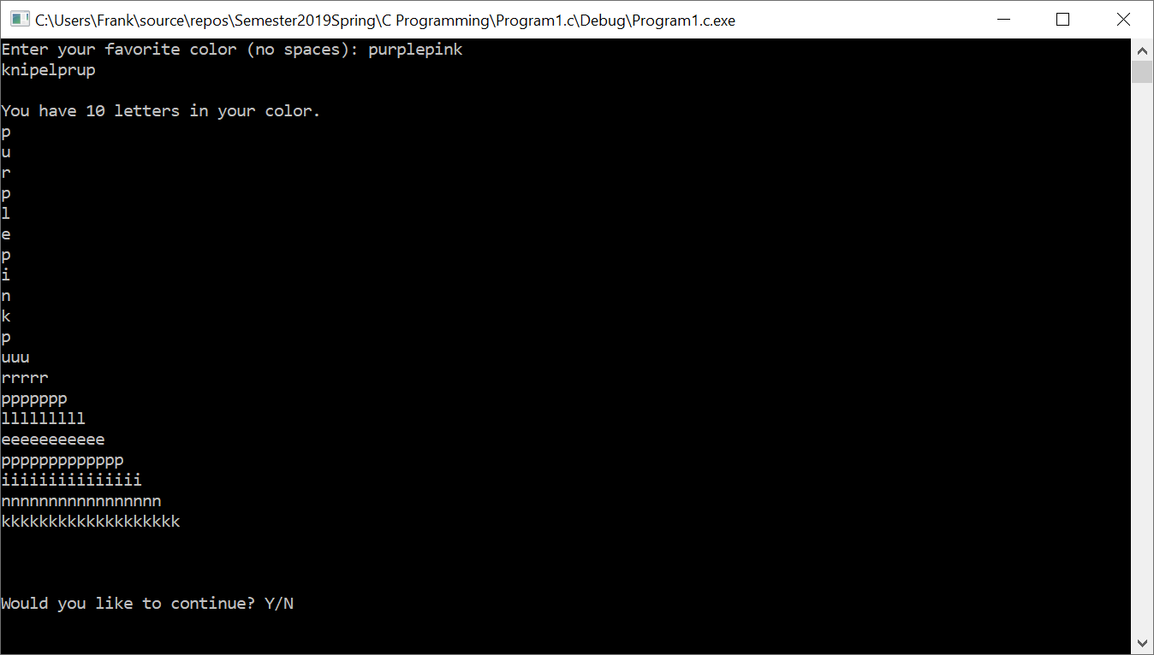

**Psuedocode:**

Program calls startColorPrinter

User enters string

Calls backward

String enters loop

Loop counts down from 98 to 0

Prints nothing for null character

Prints one character

Ends Loop

Calls vertical

String enters loop

Loop counts up from 0 to 99

Prints one character

Prints new line

Prints nothing for null characters

Ends loop

Calls triangle

Enters first loop

i equals 0

i is less than or equal to rows (10)

i adds 1

Enters second loop

k(0) is not equal to 2 times i(0) + 1

If count(0) is less than or equal to rows(10) – 1

Print one character from color[i]

Count adds 1

Else, print one character from color[i]

k adds 1

Continues second loop until statement is true

Count and k gets 0

Prints new row for triangle

First Loop continues until i is greater than rows (10)

Prints “Would You Like to Continue?”

Requests an input from user

If option equals ‘Y’

Color[i] gets new line

Calls main

Else, program returns 0.